Assignment-17.2:

Write a secondary sort program to generate the top 2 maximum temperatures corresponding to every year from the temperature dataset.

Driver Class:

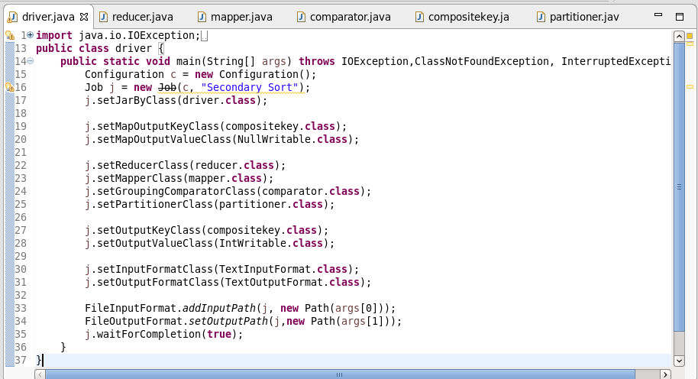

Mapper Class:

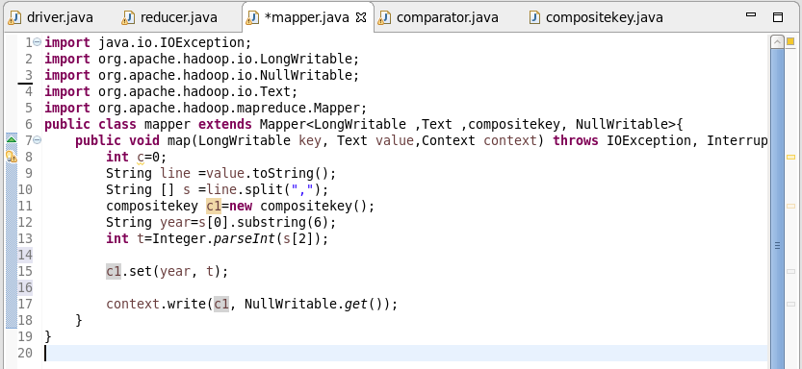

CompositeKey Class:

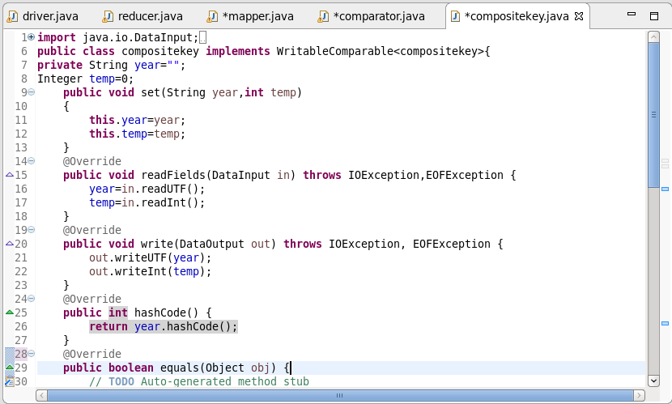

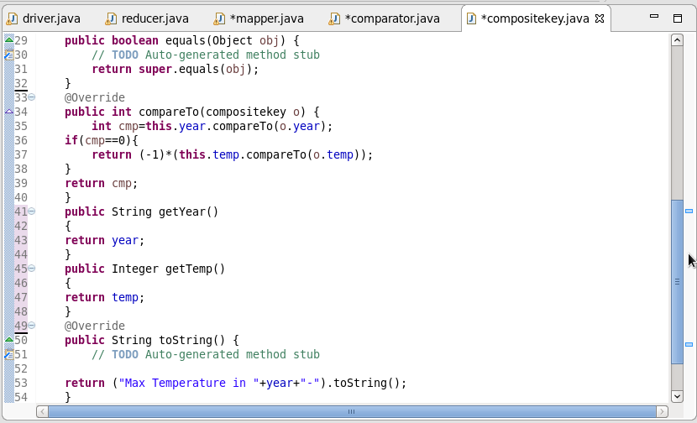

In the composite key I am comparing the year first and then the temperature and arranged in the descending order. Hence we will get the highest temp first in each of the year

Partitioner Class:

We are sending the key values pair to particular reducer on the basis of the year and the not the temp. That’s why we are over ridding the partitioner class.

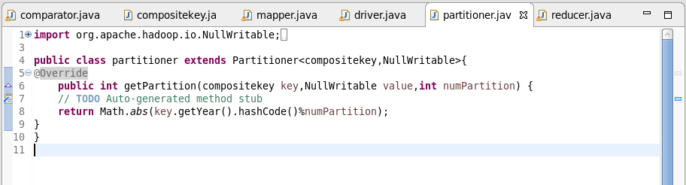

Group Comparator Class:

The Group comparator is used to group the values of each year together before going to the reducer. The grouping is also done on the basis of the year and not the composite key.

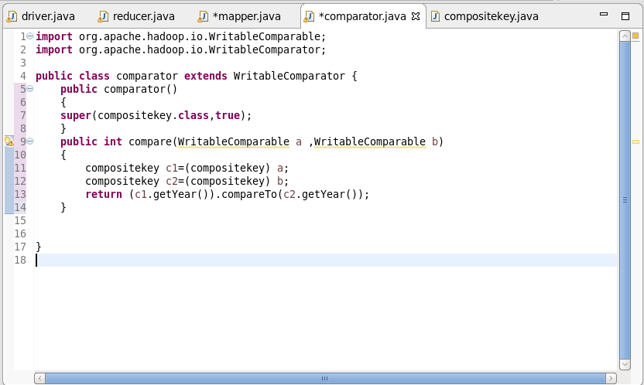

Reducer Class:

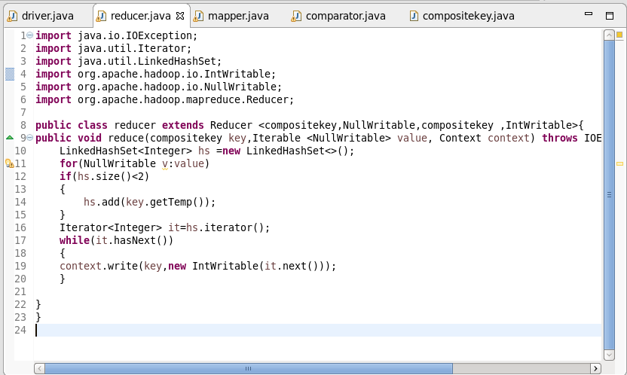

In the reducer first we are storing the values in the linked hash set to maintain the order. Hence the highest temp first and then the second highest. Also the size of the hash set is limited to 2 so that only top two values will be stored.

Running the Jar File:

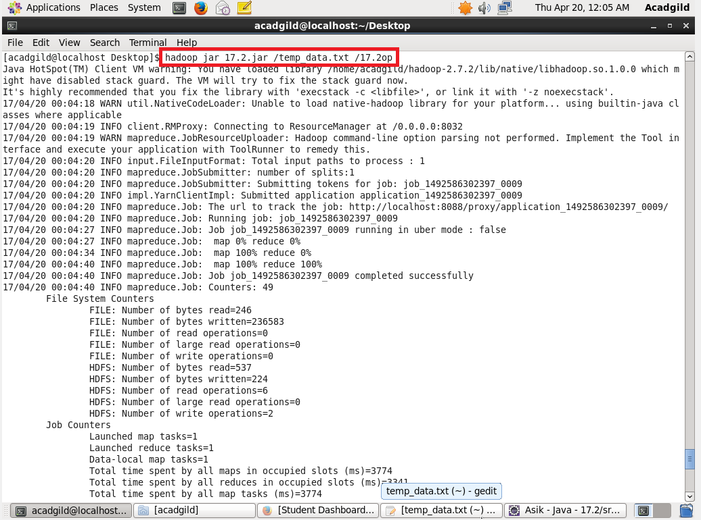

Output:

